Project Design Phase-II Technology Architecture

|  |  |
| --- | --- |
| Date | 14-10-2022 |
| Team ID | PNT2022TMID04980 |
| Project Name | Personal Expense Tracker Application |
| Maximum Marks | 4 Marks |

Technical Architecture:

The Deliverable shall include the architectural diagram as below and the information as per the table1 & table 2

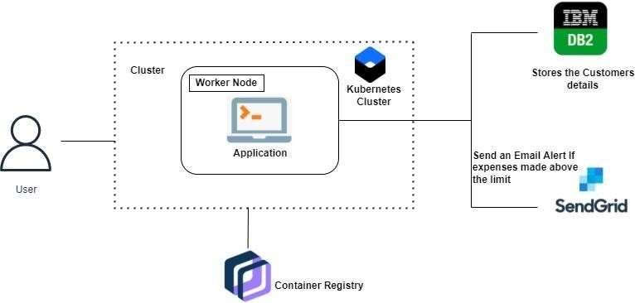

Table-1: Components & Technologies:

|  |  |  |  |
| --- | --- | --- | --- |
| **S.No.** | **Component** | **Description** | **Technology** |
| 1. | User Interface | The user can Interact with the application with use of Chatbot | HTML, CSS, JavaScript /Angular Js  / React Js etc. |
| 2. | Application Logic-1 | The application contains the sign  in/sign up where the user will logininto the main dashboard | Java / Python |
| 3. | Application Logic-2 | Dashboard contains the fields like  Add income, Add Expenses, SaveMoney | IBM Watson STT service |
| 4. | Application Logic-3 | The user will get the expense report in the graph form and also  get alerts if the expense limitexceeds | IBM Watson Assistant,SendGrid |
| 5. | Database | The Income and Expense data are stored in the MySQL database | MySQL, NoSQL, etc. |
| 6. | Cloud Database | With use of Database Service on  Cloud, the User data are stored ina well secured Manner | IBM DB2, IBM Cloudantetc. |
| 7. | File Storage | IBM Block Storage used to storethe Financial data of the user | IBM Block Storage or OtherStorage Service or Local Filesystem |

Table-2: Application Characteristics:

|  |  |  |  |
| --- | --- | --- | --- |
| **S.No.** | **Characteristics** | **Description** | **Technology** |
| 1. | Open-Source Frameworks | Flask Framework in Python is used to implement this Application | Python-Flask |
| 2. | Security Implementations | This Application Provides high security to the user Financial data.It can be done by using the Container Registry in IBM cloud | Container Registry, Kubernetes Cluster |
| 3. | Scalable Architecture | Expense Tracker is a life time access supplication. It’s demand  will increase when the user’sincome are high | Container Registry, Kubernetes Cluster |
| 4. | Availability | This application will be available tothe user at any part of time | Container Registry, Kubernetes Cluster |
| 5. | Performance | The performance will be high  because there will be no networktraffics in the application | Kubernetes Cluster |